Clock In Instruction
- Call 646-668-5963
- Press 1 to clock in
- Enter Assignment ID: __________________
- System will repeat your ID #, if it is correct. Press 1, if incorrect press 0
- Machine will register your call successfully.
Clock out Instruction
- Call 646-668-5963
- Press 2 to clock out
- Enter Assignment ID: __________________
- System will repeat your ID #, if it is correct. Press 1, if incorrect press 0
- Enter all of your duty tasks (based on POC) when done entering duties press “000”. Call will register out. *Speed Key Availability: When prompted, use the pound key (#) to speed the entry of the Duty list. There is a 5-second pause between Duty List Entry prompts if the pound key is not pressed

Clock in at the beginning of your work day. Clock out at the end of your work day. For Live- In cases, clock in on first day of work only, every day after that you will only clock out (using the #2 and your DUTY ID’s)
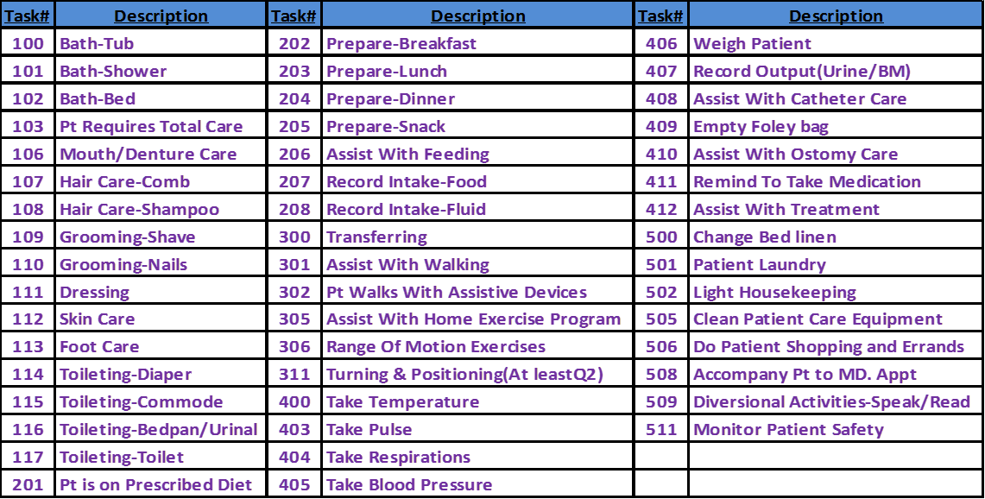
***YOU MUST DIAL 511 ON ALL CASES***

