Empeon Hub (Online Paystub) Instructions

We are pleased to now provide you with a new, enhanced portal to review your paystubs online. You will find this site to be easy to use and it will support access from mobile devices and tablets. Please see additional information below.
Please Note: Internet Explorer is not supported for Empeon Hub. Recommended internet browsers are Chrome or Firefox.
- Provide your email to your payroll department. You will soon receive an email like the example below from notifications@mail.empeon.com inviting you to register. Click the “Register Account” link in the email.

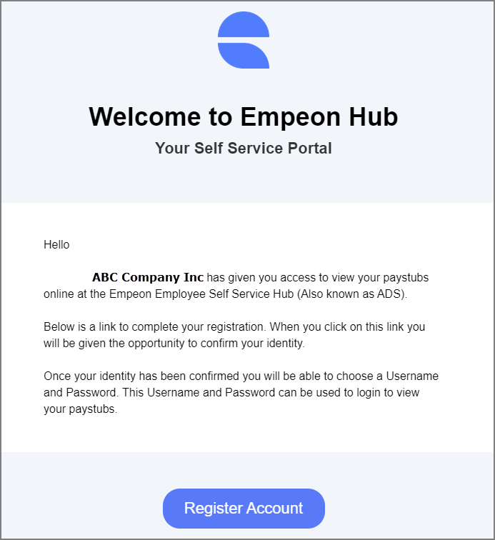

- The “Register Account” link will take you to a secure web portal. You will first be required to verify your identity by keying in your social security number. You will then be instructed to create your unique username and password.
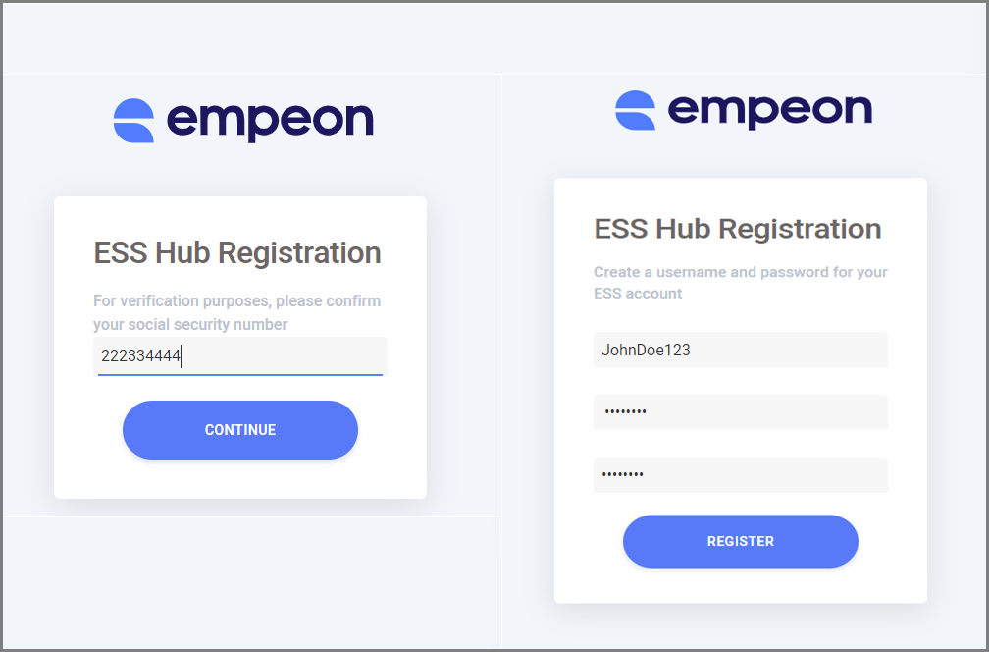

- Once you are notified that your registration is successful, click the “Go To Sign In” link. You will be redirected to https://hub.empeon.com to sign in and view your paystubs. You can visit this website at any time to review your pay information.
- The first screen after login will show the pay info from your latest check date. Click the “View Paystub” link to see an online PDF of the paystub. You also have the option to “Download Paystub” to your PC or device.
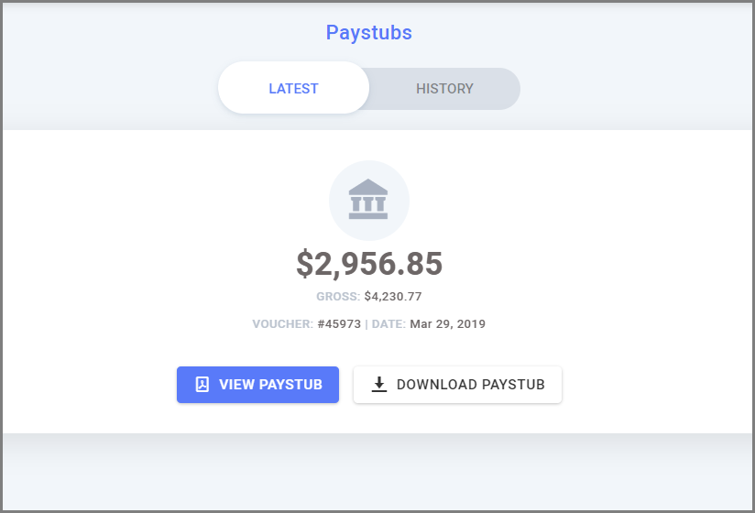

- To see pay stubs from previous pay periods, click the “History” option on top of the screen. Pay records are organized by month and year. Click Expand Icon to view and download any stub.
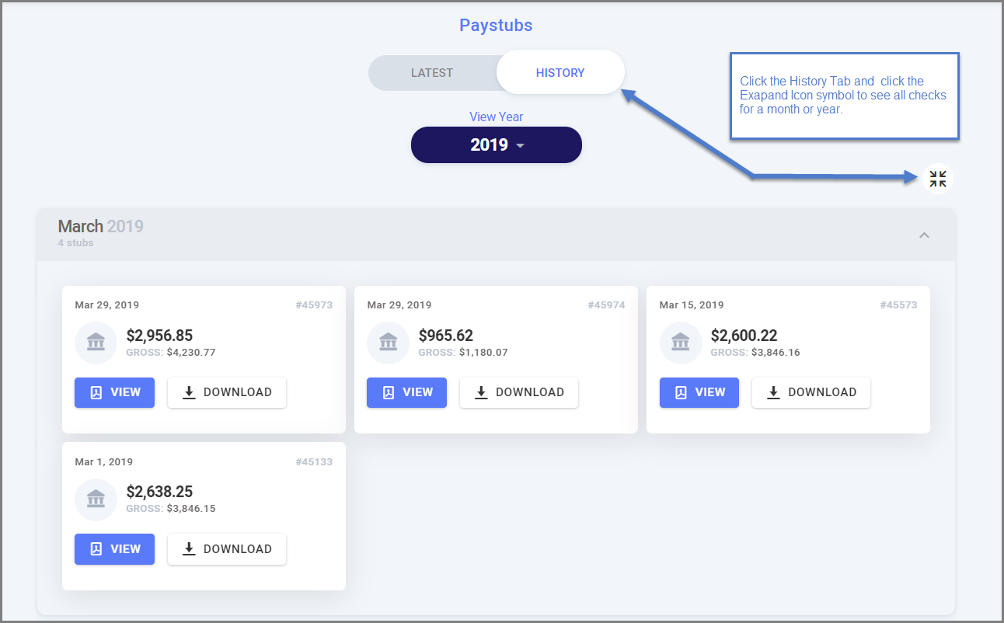
- If you forget your Username or Password, you can reset your Password or verify your username by clicking the associated links in the Sign-in page.

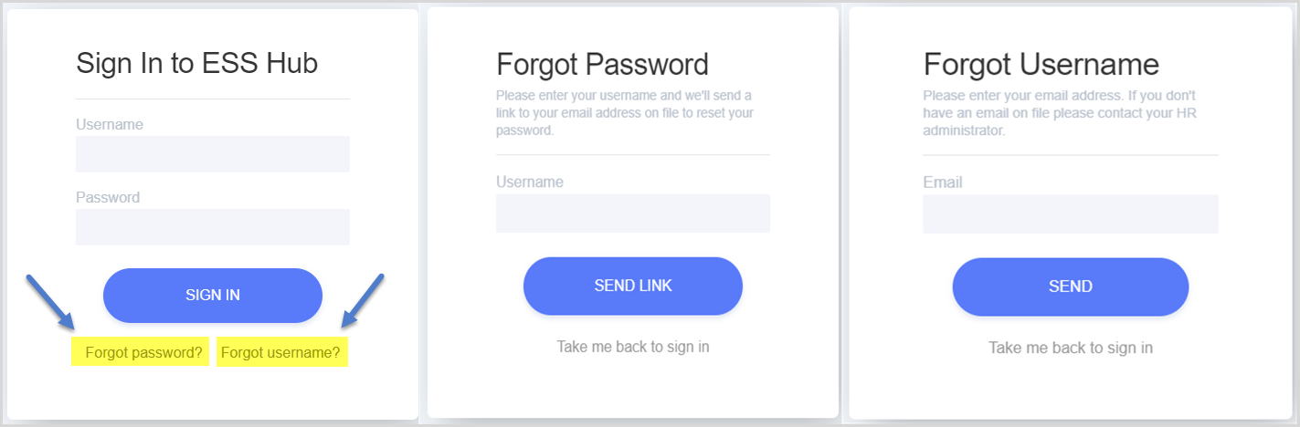

* For any issues you have in logging in or viewing your pay records, contact your payroll department for assistance *

